Scientific Writing and Research Methodology PSPHY PR1, (M. Sc. Physics 4th Sem)
Credits 4 LTPS (3106)

Teacher In charge: Dr. S.Rubab

Module 1: Introduction to Philosophy of Science, what is science? Scientific reasoning; Scientific Method, Explanation in science; Realism and instrumentalism; Scientific Temper.

What is science: Science is a systematic enterprise that builds and organizes knowledge in the form of testable explanations and predictions about the universe around us. Since the earliest civilizations of Mesopotamia, Egypt, Indus valley etc., human became interested in sciences like medicine, materials and metallurgy, mathematics and astronomy. Greeks and then Romans further developed these sciences and provided philosophical base and induction. The Greeks were mainly speculators or theorists. The sciences were further refined by Muslims from 7th to 15th century. The Islamic scientist gave more emphasis to experiments and logical reasoning. The Arabic translation and commentary on Greek sciences as well as Arabic sciences reentered Europe through Spain via Latin translation and helped in revival of Natural philosophy in Europe. This led to scientific revolution of 16th century in Europe. Sciences and Modern scientific method took shape till 19th century in Europe and natural philosophy gave way to Natural Sciences. Natural sciences were further divided into physical, chemical, life and applied sciences. In twentieth century, the pursuit of sciences became global. The growth of science is based on research which is being conducted in academic and research and development organizations.

Modern Scientific Method:

Hypothesis/thought experiments
Observation/Experimentation
Analysis/Modeling
Conclusion/forecast
Verification/falsification

Reproducibility of experiments is essential.

Verifiability is fundamental for scientific growth.

Falsifiability is the hallmark of modern scientific method A scientific theory is empirical and is always open to falsification if new evidence is presented.

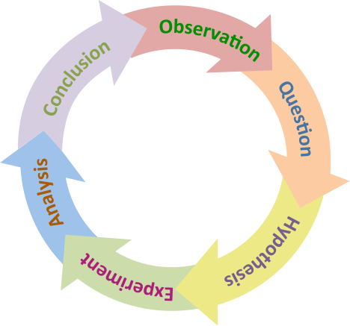

The scientific method is a continuous cycle of hypothesis, prediction, testing and questioning.

When a hypothesis proves unsatisfactory, it is either modified or discarded. Disproof of a prediction is also an evidence of progress of Science. If a hypothesis is proved it becomes a law or theory. Modern scientific research is based on transparency and peer review.

Philosophy of science

Scientists usually take for granted a set of basic assumptions that are needed to justify the scientific method: (1) that there is an objective reality shared by all rational observers; (2) that this objective reality is governed by natural laws; (3) that these laws can be discovered by means of systematic observation and experimentation. Philosophy of science seeks a deep understanding of what these underlying assumptions mean and whether they are valid.

Realism: The belief that scientific theories should and do represent meta physical reality is known as realism.

Instrumentalism: It emphasizes the utility of theories as instruments for explaining and predicting phenomena. It views scientific theories as black boxes with only their input (initial conditions) and output (predictions) being relevant. For example, many people have difficulty in interpreting quantum mechanics but as long as it gives good predictions it is fine.

Scientific temper: It means an enquiring attitude and analytical approach that leads to rational thinking and the pursuit of truth without prejudice. Scientific temper is an attitude of mind which calls for a particular outlook and pattern of behaviour. The spirit of enquiry and the acceptance of the right to question and to be questioned are fundamental to scientific temper. It recognises the fact that knowledge often progress by disproving earlier ideas, beliefs, theories and laws. It considers knowledge as open ended and ever evolving. Scientific temper and humanism are included as fundamental duty of all citizens in our constitution in 1976.

Hands on science activities, science movements, science museums and extension centres play important role in building scientific temper among masses. Science fiction can also be used to inculcate scientific temper. Science communication and rational thinking has played a great role in diluting superstitions associated with natural phenomenon like solar or lunar eclipses.

Source: Wikipedia

